《商务英语阅读1》课程教学进度计划表
一、基本信息
课程名称 | 商务英语阅读1 / Business English Reading 1
课程代码 | 2020597 | 课程序号 | 2234 | 课程学分/学时 | 2 (32)
授课教师 | 陈维 | 教师工号 | 22537 | 专/兼职 | 专职
上课班级 | 商英B24-1 | 班级人数 | 32 | 上课教室 | 三教310
答疑安排 | 星期四7-8节，外国语334
课程号/课程网站 | 2365779  https://my.gench.edu.cn/FAP5.Portal/pc.html?rnd=177110643
选用教材 | 《商务英语阅读教程1》 王立非总主编，叶兴国、谢文怡主编ISBN 9787544659697，上海外语教育出版社，2023年8月第1版
参考教材与资料 | 1.《商务英语综合教程1》王立非主编，ISBN：978-7-5446-4650-5  上海外语教育出版社  2．《商务知识导读》，孙丽霞、王欣双著，北京对外经济贸易大学出版社；  3. 自编资料包  4. www.chinadaily.com.cn

二、课程教学进度安排
课次 | 课时 | 教学内容 | 教学方式 | 作业
1 | 2 | Course introduction and requirements；  Unit 1 Effective Communication  Extensive Reading: Text A  Reading Skills | 讲述教学，任务教学，问题导向教学，讨论教学 | Supplementary Reading;  Test Yourself
2 | 2 | Unit 1 Effective Communication  Extensive Reading: Text B  Unit 2 Soaring China  Extensive Reading: Text A  Reading Skills | 讲述教学，任务教学，问题导向教学，讨论教学 | Supplementary Reading;  Test Yourself
3 | 2 | Unit 2 Soaring China  Extensive Reading: Text B  Unit 3 Gender Discrepancy  Extensive Reading: Text A  Reading Skills | 讲述教学，任务教学，问题导向教学，讨论教学 | Supplementary Reading;  Test Yourself
4 | 2 | Unit 3 Gender Discrepancy  Extensive Reading: Text B  Reading Skills  Quiz 1 | 讲述教学，任务教学，问题导向教学，讨论教学 | Supplementary Reading;  Test Yourself
5 | 2 | Unit 4 Staff Management  Extensive Reading: Text A & Text B  Reading Skills | 讲述教学，任务教学，问题导向教学，讨论教学 | Supplementary Reading;  Test Yourself
6 | 2 | Unit 5 Consumer Behavior  Extensive Reading: Text A & Text B  Reading Skills | 讲述教学，任务教学，问题导向教学，讨论教学 | Supplementary Reading;  Test Yourself
7 | 2 | Unit 6 Corporate Social Responsibility  Extensive Reading: Text A  Reading Skills  Quiz 2 | 讲述教学，任务教学，问题导向教学，讨论教学 | Supplementary Reading;  Test Yourself
8 | 2 | Unit 6 Corporate Social Responsibility  Extensive Reading: Text B  Unit 7 Career Success  Extensive Reading: Text A  Reading Skills | 讲述教学，任务教学，问题导向教学，讨论教学 | Supplementary Reading;  Test Yourself
9 | 2 | Unit 7 Career Success  Extensive Reading: Text B  Unit 8 Positive Attitudes  Extensive Reading: Text A  Reading Skills | 讲述教学，任务教学，问题导向教学，讨论教学 | Supplementary Reading;  Test Yourself
10 | 2 | Unit 8 Positive Attitudes  Extensive Reading: Text B  Unit 9 Time Management  Extensive Reading: Text A  Reading Skills | 讲述教学，任务教学，问题导向教学，讨论教学 | Supplementary Reading;  Test Yourself
11 | 2 | Unit 9 Time Management  Extensive Reading: Text B  Reading Skills  Quiz 3 | 讲述教学，任务教学，问题导向教学，讨论教学 | Supplementary Reading;  Test Yourself
12 | 2 | Unit 10 Green Business  Extensive Reading: Text A & Text B  Reading Skills | 讲述教学，任务教学，问题导向教学，讨论教学 | Supplementary Reading;  Test Yourself
13 | 2 | Unit 11 Ways of Investment  Extensive Reading: Text A & Text B  Reading Skills | 讲述教学，任务教学，问题导向教学，讨论教学 | Supplementary Reading;  Test Yourself
14 | 2 | Unit 12 Era of Big Data  Extensive Reading: Text A  Reading Skills  Quiz 4 | 讲述教学，任务教学，问题导向教学，讨论教学 | Supplementary Reading;  Test Yourself
15 | 2 | Unit 12 Era of Big Data  Extensive Reading: Text B  Reading Skills | 讲述教学，任务教学，问题导向教学，讨论教学 | Supplementary Reading;  Test Yourself
16 | 2 | Review for the final test | 讲述教学，任务教学，问题导向教学，讨论教学 | Review
三、考核方式
总评构成 | 占比 | 考核方式
1 | 50% | 期末笔试
X1 | 20% | 随堂测试
X2 | 20% | 读书报告
X3 | 10% | 考勤及课后作业

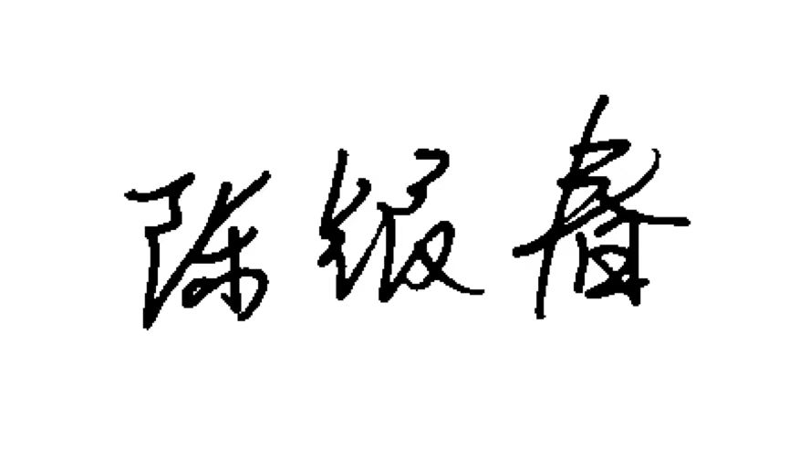

任课教师： 系主任审核： 日期：2024.9

